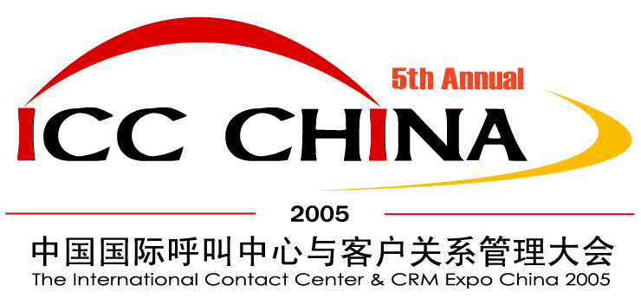
2005年4月11日—15日
April 11 – 15, 2005

中国 上海 光大会展中心
Everbright Convention & Exhibition Center, Shanghai, P.R.China
The Largest Gathering of Call Center and Customer Management Professionals in Asia-Pacific
2005中国国际呼叫中心与客户关系管理大会
The International Contact Center & CRM Expo China 2005

The 5th Annual Conference & Expo on  Contact Center Management & CRM Solution China  Exceeding your customer’s expectation to develop profitable customer relationships and win a competitive advantage !  Official Endorser:    Supported by:              Produced by:   | A MUST ATTEND for all Customer Service Organization !  5th Annual ICC China Conference & Exposition, an unparalleled event in China for customer contact management and CRM solution.  Some of the highlights for this year's ICC China 2005 program include:  - Industry-leading exhibitors  - CRM Solutions sessions  - Customer Learning Conference  - Famous world-class expert dedicated seminar  - Awards presentation, the 2005 China Best Call Center & CRM of the Year  - Site tours to Shanghai area call centers  - Keynote addresses given by industry leaders and a thought-provoking Power Panel general session  - Courses for call center professional certification  - Industry Forums held on the show floor, offering an in-depth look at the latest trends & technologies  - Technology solutions presented by leading exhibitors and sponsors  - Exhibit hall happy hour
Why You Should Attend ICC China 2005  China is a large country and has huge population; it possesses various industries and enjoys large development space for the market. Today, China is the biggest potential market for Contact Center and CRM in the world, the most important things is that it's just begin! | 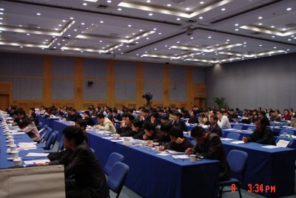

Conference & Expo Agenda

April 12, 2005 | Call Center Site Tours
April 12, 2005 | 1st Site Visit | 2nd Site Visit
09:30am - 11:30am | Call Center A | Call Center B
 | Lunch
02:00pm - 04:00pm | Call Center C | Call Center D

April 13, 2005
09:15am – 09:25am | Opening Ceremony
09:30am – 10:15am | AltiGen: Mr. Gilbert Hu, President of Asia-Pacific Area  ——The New Trend of Call Center Market in North American
10:15am – 11:00am | Avaya: Mr. Mao Yixing, CRM Senior consultant  ——The Best Practice in Call Center
11:00am – 11:15am | Coffee Break
11:15am – 12:00am | Mr. Brad Cleveland, President of Incoming Calls Management Institute, U.S.A.  ——The Secret of high-efficient management of call center
 | Lunch
01:15pm – 02:00pm | Alcatel:
02:00pm – 02:45pm | Hua Wei:
02:45pm – 03:00pm | Coffee Break
03:00pm – 03:45pm | eOn Communications: Mr. Troy Lynch, President of Asia-Pacific Area  ——The new trend to change the call center
03:45pm – 04:30pm | Intel:
06:00pm – 07:30pm | Banquet for Expo Opening  China’s Best Call Center & CRM of the Year Awards

April 14, 2005
 | Operation and Management of Call Center | Technology and Application of Call Center and CRM |  |  | Industry Study of Call Center and CRM
09:30am – 10:10am | Teleweb: Mr. Baumin Li, President,  ——whole implementation method of World-class service level | Continuous Technology Inc.:  ——IP Multipoint distributed Call Center----CIC |  |  | Grandsys Technology & Service Corp.: Mr. Huang Zhongxi, Manage of Call Center Dept.  ——YOUR COMPLETE SOLUTION FOR OPTIMIZING WORKFORCE PERFORMANCE
10:10am – 10:50am | Witness Systems: Mr. Jose S. Rosenbaum  Title: Senior Sales Manager, International  ——CONTACT CENTRE WORK FORCE OPTIMISATION | AltiGen: Mr. Samuel Qiang, Manager of Technique Service  ——IP Distributed Call Center |  |  | Beijing Jiaxun Feihong Electrical Co., Ltd.
10:50am – 11:10am | Coffee Break
11:10am – 11:50am | Taiwan Call Center Development Association: Mr. Alex Chien, Chairman  ——The Trend of Call Center Industry and Value-add Service | CosmoCom: Mr. Ma Minxiong, General Manager of Grand China Area  ——Call Center on Demand |  |  | Sagatori: Mr. Simon Kriss, CEO  ——
 | Lunch
01:30pm – 02:10pm | China Merchants Bank: Mr. Liu Jianjun, General Manger of Individual dept.  ——Increasing the value of Call Center, building the service system of CMB follow up the international standard |  | Avaya: Mr. Mao Yixing, CRM Senior consultant  ——Through initiative outbound service to create value | Shanghai Pudong Development Bank:
02:10pm – 02:50pm | Ubest Management & Consultation Co., Inc.: Mr. Fan Jun, Authentication Director  ——CCCS Standard－The direction sign of call center standardization operation & management |  | eSOON: Mr. Li Qiyuan, Senior Consultant of Business Module  ——Making the customer service centre in the future, an advanced operation experience to share | TeamSun:
02:50pm – 03:30pm | Coffee Break
03:30pm – 04:10pm | Shanghai Volkswagen: Mr. Xin Jingchun, Manager of Customer Department  ——Keep the customer’s loyalty by “CRM” |  | ITApps Information Technology Co., Ltd: | Samsung life of Korea: Mr. 고영근  ——The Research of Customer Service for Insurance Industry
04:10pm – 04:50pm | Guangdong CNC: Ms. An Xin, Manager of customer service  ——Improve the service level of CNC according to CCCS |  | Telemarketing Institute, Inc. U.S.A.: Ms. Mary Pekas,  —— | Ping An Insurance Group: Mr. Hu Haibo, General Manager of Customer Service  ——How Call Center services to Insurance Industry?
06:30pm – 08:30pm | A Party for Call Center Manager Association (CCMA)

April 15, 2005
 | Operation and Management of Call Center | Technology and Application of Call Center and CRM | Industry Study of Call Center and CRM
09:30am – 10:10am | TCL Mobil Communications Inc.: Mr. Xiao Feng, Vice General Manager  —— | SHANGHAI NETCOM SCIENCE & TECHNOLOGY CO., LTD.: | Sephoncom communication Co.Ltd.: Mr. Huang Yuhui, Vice General Manager  ——The New Method of Building Call Center for Enterprise
10:10am – 10: 50am | Bertelsmann: Mr. Ai Mier, CEO of Grand China Area  —— | CosmoCom: Mr. Rayman Wong, General Manager of Asia-Pacific  —— | HOLLYCRM: Mr. Lu Yi, Vice President  ——The Road to Success for Government and Enterprise
10:50am – 11:10am | Coffee Break
11:10am – 11:50am | Korea Callcenter Information Research Center: Professor Mr. Cheong ki ju  —— | Shanda Networking Group: Ms. Wang Jingying, Vice President  —— | CTI forum: Mr. Kerry Qin, Marketing Director  ——The Trend of China Call Center Industry
 | Lunch
01:30pm – 03:30pm | Experts Free Forum

The Open Time of Expo Hall：April 13, 1:30pm —— April 15, 3:30pm

(Attending any of campaigns for Conference & Expo, pre-registration is required.)

Who should Exhibiting

If you are a supplier of call & contact center products and CRM solution, services, including:

Call & Contact Technology  Integrated Call Center Systems  Call Center Software  Call Management Systems  Communication Servers  PABX / Switches  CTI  IVR (Interractive Voice Respond)  ACD (Automatic Call Distribute)  Voice Process/ Messaging  Voice Based System Integration  Speech Recognition Software  Unified Messaging Systems  Database  Headsets  Call Logging Systems  Internet & Web-Enabled Call Center  Internet Telephony and fax  Web-based Service and Support Technology  Data Recorders  Bureau Services / Teleservices  Outsourcing services  Telecommunication services  Telemarketing service providers  Consultancy Services | CRM  Customer Relationship Management Software  Customer Support Management Solutions  Database software, services and management  Loyalty and eLoyalty programmes  Customer Information Systems  People & Workplace  Construction Design  Workforce Management  Lead Generation and Tracking Technology  Quality Monitoring  Training / scripting consultants  Recruitment  Retention  Motivation and Human Resource Management  Siting/Location  Business process & Strategy  Business Continuity Consultancy  Customer Relationship Management (CRM)  eBusiness Measuring  Multi-Media Contact Strategy  Star-up Call Centers  Local and Remote Contact Solutions  Marketing Information Systems  Customer Information Systems
and any organisation that provides call Center or CRM related products or services, then you should be exhibiting at Contact Center Management & CRM Solution China 2004 !
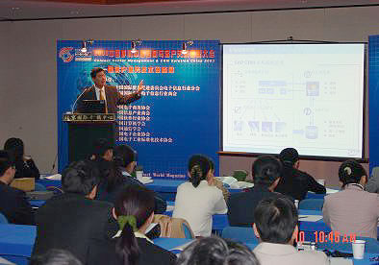 | 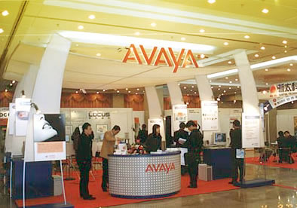

Pricing Guide

- Sponsorship:

Main Sponsor | US$ 30,000 | See "Sponsor Metrics"
Special Sponsor | US$ 13,000 | See "Sponsor Metrics"
Sponsor | US$ 7,000 | See "Sponsor Metrics"

- Meeting Cost:

Keynote | US$ 4,500 / 45 minutes
General Session | US$ 1,800 / 40 minutes

- Exhibiting Cost:

Demonstrate Place  （9 sqm, a booth） | US$2,500 / per
Demonstrate Place  （9 sqm, a booth） | A ready-for-display package stand has been designed for exhibitors to use a cost-effective way of participation.  Includes partition walls on three closed sides of the stand, (two panel walls for the two-entrance stand, which the reservation in advance and additional 10% charge is necessary).  One information counter, Two chairs, Fascia board with exhibitor's English and Chinese name thereon, Carpet full booth, Two spotlights, One 5A/220V socket and stand cleaning.
Original Place  （27 sqm） | US$ 4,860 / per
Original Place  （27 sqm） | All the exhibitors please send the company briefing (both Chinese and English) to the Organizing Committee before March 15th for related proceedings making. Decoration and construction management fee for the raw space in demo area will be responsible by the exhibitors themselves.

- Optional Supplies & Services:

Advertisement in the Exhibition Directory | The Cover Page and Extend Page (color): | US$1,800 / page
Advertisement in the Exhibition Directory | Back Cover Page (color): | US$1,600 / page
Advertisement in the Exhibition Directory | Back Cover Extend Page (color): | US$900 / page
Advertisement in the Exhibition Directory | Second Seal: | US$800 / page
Advertisement in the Exhibition Directory | Third seal: | US$800 / page
Advertisement in the Exhibition Directory | Inside Page: | US$600 / page
Advertisement in the Exhibition Directory | President Oration (one color, photo): | US$450 / page
Advertisement in the Exhibition Directory | The cost for translation, typing, proofread artwork and colors separation is excluded.
Company Logo on the Theme Board | US$ 450 / per / duration
Inflating Rainbow Gate outside the conference main entrance | US$1,800 / per / duration
Inflating Rainbow Gate outside the conference main entrance | Size: 5.6m high x 10m span with a 10m x 0.5m banner
Inflating Balloon outside the conference main entrance | US$1,800 / per / duration
Inflating Balloon outside the conference main entrance | Size: 3.5m diameter with a 12m long banner
Site Advertisement | US$450 / per / duration
Site Advertisement | Two sides of the main entrance, exhibition halls and conference halls
Advertisement on representatives belt | US$900; 5,000 pieces
Advertisement on material bags | US$2,700; 5,000 pieces
Advertisement on the back of entrance permission | US$900; 5,000 pieces
Conference gift sponsor | US$2000
Conference gift sponsor | Logo on the sponsored lucky draw gifts
Conference souvenir sponsor | US$2000
Conference souvenir sponsor | Logo on the conference souvenir  5,000 pieces
Outdoor advertising banner | US$ 90.00 / per / duration
Outdoor advertising banner | Size: 0.7m x 1.6m, literal ad., one color silk screen printing

- Sponsor Items:

Naming Banquet on April 13,2005 Evening | US$5,400
Naming Banquet on April 13,2005 Evening | Sponsor's speech 5-10min and the backboard with Logo can be arranged
Coffee Break Sponsor for April 11-15 | US$3,600
Coffee Break Sponsor for April 11-15 | Sponsor's speech can be arranged

For more supporting ways, please contact to the Show Management for details

Sponsor Metrics

"A" Main Sponsor US$30,000  Benefits:  - Keynote speech (General Manager level above) 45min.  - Two divisions in General Session 80min.  - Offer necessary Demo space (27 square meters)  - Company Logo on the Main Back Board, the Proceeding and media  - Become the sponsor of Banquet on April 13,2005 Evening  - Advertisement on representatives belt  - One Back Cover page of colored ad & 300 -500 words of company introduction on the Proceedings (Both Chinese and English)  - Advertisement on the column of ICC China 2005 of CTIforum and the homepage of http://www.crmunion.com (Size: 140 x 120 pixels)  - Interview with the conference specified media can be arranged.  - Help spread the company brochures, gifts and publications  - One cube of indoor advertisement  - Four of free individuals' registrations for Banquet on April 13,2005 Evening  - 5 min speech on Opening Ceremony and the Banquet on April 13,2005 Evening  "B" Special Sponsor US$13,000  Benefits:  - One session in General session 40 min  - Provide necessary Demo space (27 square meters)  - Becoming the Special Sponsor company of the Coffee Break | - One cube of indoor advertisement  - Company Logo on the Main Backboard, the proceeding and the media  - One page of colored ad & 300-500 words of company introduction on the Proceeding (Both Chinese & English)  - Advertisement on the column of ICC China 2005 of CTIforum and the homepage of http://www.crmunion.com (Size: 140 x 90 pixels)  - Two of free individuals' registrations for Banquet on April 13,2005 Evening  "C" Sponsor US$7,000  Benefits:  - One session in General session 40min  - Provide necessary Demo space (Two standard booths)  - Company Logo on the Main Backboard, the proceeding and the media.  - One page of colored ad & 300-500 words of company introduction on the Proceeding (Both Chinese & English)  - Advertisement on the column of ICC China 2005 of CTIforum and the homepage of http://www.crmunion.com (Size: 140 x 60 pixels)  - Two of free individuals' registrations for Banquet on April 13,2005 Evening  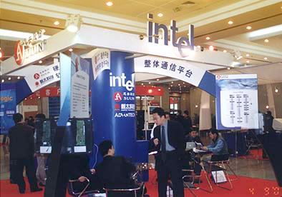

Event at a Glance

Site Tours
The call center site tours give you an inside view of China's most advanced centers. Take this unique opportunity to meet other managers and industry experts, learning about the technologies they use, the challenges they face, improvements they have made and successes they have realized. See how your operation sizes up!

CCMA Party
Topics that are hotly debated will be addressed by a panel made up of international and local experts. This is where you get an up-front view of the real thoughts behind the issues. Get involved during the question and answer segment but be prepared for a straight up response.

Awards presentation
The 2005 China's Best Call Center & CRM of the Year Awards. You can meet them and learn more about these committed, best-of-class individuals, and to celebrate the evolution of the call center industry around China.

World-class Expert Course of lectures
Invite world-class expert to give a dedicated course of lecture for Contact Center management and CRM solution. Speak to them, get their expert advice and make it happen in your company.

China’s Best Call Center & CRM of the Year Awards

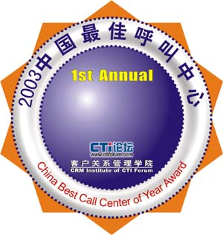 | Jointly presented by the China Customer Relationship Management Committee, CTI Forum and ICC China 2005, the award recognized leading companies in China that have implemented innovative and dynamic customer-driven strategies that deliver clear and quantifiable customer benefits.
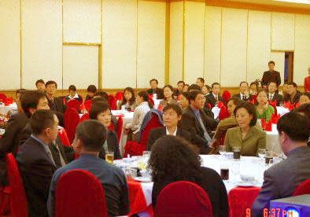 | 